Dear Families,

Raising Achievement Evening
Firstly, a massive thank you and well done to the parents and students who attended our annual Year 11 Raising Achievement Evening yesterday. It is such an important time for students who are approaching their GCSE assessments and with only 27-weeks of school remaining, it is vital that we all make that time count! The main outcome of this evening is that all Year 11 students must now complete a list of key topics and a revision plan. We expect parents to be the best quiz masters in the entire land and to regularly engage in short bursts of quizzing with their children to further embed learning.

Please note the additional information that was shared with Year 11 students on our website here

SEND Parent Forum
We were thrilled to receive such a fantastic turnout at the first SEND Parent Forum of the academic year hosted by Mrs McNair (College Leader – SEND Strategic Lead). Thank you to all parents who attended for such thoughtful, useful, and positive contributions. We continue to prioritise communication with families of children with SEND and these regular forum opportunities have been brilliantly well attended. The next opportunities for SEND parents to engage with the school will be a SEND Coffee morning next half term (date to be confirmed) and a SEND Parent Forum on Wednesday 17th January 2024.

Free School Meals
We strongly urge parents who may qualify for Free School Meals to apply via the following websites:
- Leicestershire County Council
- Northamptonshire County Council

Your child may be able to get free school meals if you get any of the following:
- Income Support
- Income-based Jobseeker’s Allowance
- Income-related Employment and Support Allowance
- Support under Part VI of the Immigration and Asylum Act 1999
- The guaranteed element of Pension Credit
- Child Tax Credit (provided you’re not also entitled to Working Tax Credit and have an annual gross income of no more than £16,190)
- Working Tax Credit run-on - paid for 4 weeks after you stop qualifying for Working Tax Credit
- Universal Credit - if you apply on or after 1 April 2018 your household income must be less than £7,400 a year (after tax and not including any benefits you get)
- Please note that children who get paid these benefits directly, instead of through a parent or guardian, can also get free school meals.

If you require any assistance with completing an application, please get in touch by emailing the school office and requesting a call back from Mrs Osborne (SEMH Manager).

Extra-Curricular Opportunities
There is no shadow of a doubt that our students benefit from outstanding provision, and this includes an enviable extra-curricular programme which we know our students highly value. This week, all students have attended participation assemblies led by their College Leader. These assemblies have provided students with an overview of extra-curricular opportunities and our message is simple; take every opportunity!

(Cont...)
These opportunities include:
- Art Club
- Art Council
- Charitable Action in Robert Smyth (CAIRS)
- Dance Company
- Drama Club
- Duke of Edinburgh Award
- Eco-Schools Committee
- Global School Alliance Competition
- Homework Club
- Junior choir, Jazz Band and Soul Patrol
- Mandarin Lessons
- Planning and delivery of a Tutor Group Assembly
- School Council
- Sports: Badminton, Basketball, Cross Country, Football, Netball, Rugby, Swimming Galas (Autumn)
- Sports Leadership Qualification
- STEM Science Club
- String, sax, brass, percussion, and flute ensembles
- The Library
- Write Club

In addition, all students have access to a Virtual Wellbeing Box on the website which allows them to raise any questions, provide feedback or share any concerns. The inbox is reviewed every Tuesday as part of the Senior Leadership Team Meeting Agenda.
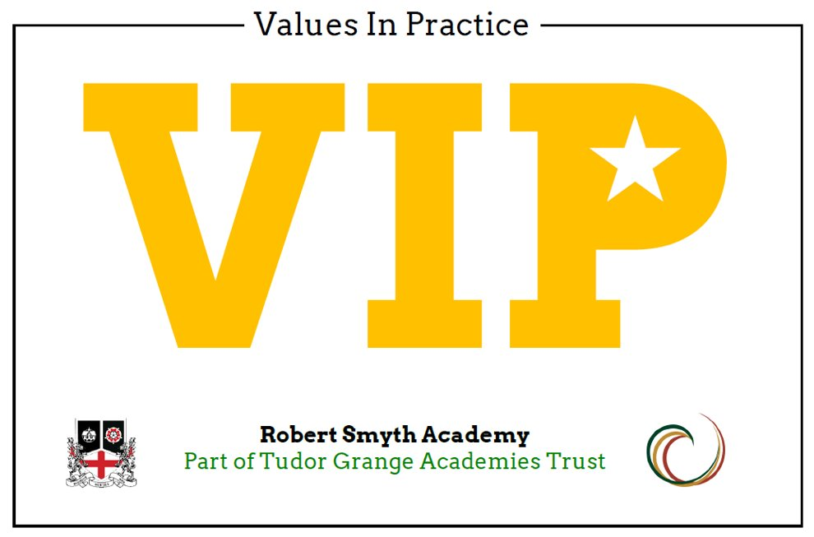
Values in Practice: Respect – Succeed - Aspire
Firstly, I wish to commend Owen (Year 13) for winning the PDC Young Drummer of the Year competition. This is an incredible achievement, and Owen has been invited to produce his own masterclass and recordings as a result. Anyone who has seen Owen perform will know that this accolade is well-deserved.

I would also like to commend Georgie (Year 12) for her outstanding presentation to Year 11 students and their parents last night at Raising Achievement Evening. Georgie spoke with authenticity about her experiences of managing exam stress, revision, and the timeline of her final year of school including an analysis of the revision benefits of teaching chemistry to a cat which was a clear highlight of the evening for parents! Georgie continues to be an incredible contributor to our school and a true RSA Ambassador.

Finally, a special mention to our U18 Rugby Team who performed with real grit and tenacity against Oundle School yesterday. One of our school values that is very close to my heart is the importance of showing the bravery to achieve success. I was proud of the team spirit and hard work that these students put into their performance against a team that arrived with their own camera crew, a mass of coaching staff and many players who would not have looked out of place in Gold’s Gym on Venice Beach! Undeterred, our students were courageous, and we did not take one step back. Well done to the PE Team for their sterling efforts!
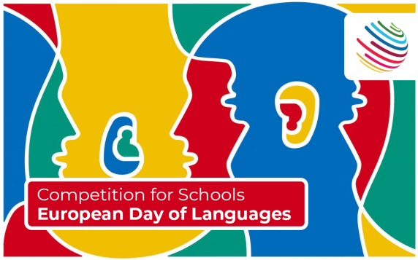
Global Schools Alliance Competition: Competition for Schools European Day of Languages
Written by Ms. Hadfield

To celebrate the European Day of Languages on 26th September, Robert Smyth Academy is taking part in an international competition, organised by the Global Schools Alliance!

The theme of the competition is ‘For me, learning a language is…’

You can get creative and submit an entry in whatever form you want, for example: presentations, videos, drawings, photographs, short articles, a piece of creative writing. Global Schools Alliance say, “We want students to tell us what learning a language means to them. We want to showcase the magic and importance of language learning”.

How will this be judged?
We can submit one entry to represent Robert Smyth Academy in this global competition. We will select an entry from all submissions on Monday 2nd October.

The overall winners will be picked by a panel of three judges at Global School Alliance.

We will be looking for:
a) creativity
b) presentation
c) use of language

What are the prizes?
All students who submit an entry will receive a postcard home and there will also be a prize for our chosen international competition entry (a £20 ‘Love to Shop’ voucher).

The overall winner will be chosen by Global School Alliance an online awards ceremony on 17th October.
The prizes are the following:

1st Place – Digital School Partnership for Robert Smyth Academy and a £50 Amazon Voucher
2nd Place – £25 Amazon Voucher

How do I submit an entry?
Please send all entries to Ms Hadfield by e-mail: jhadfield@robertsmyth.tgacademy.org.uk or entries can be submitted to A5 (Bragg Hall) before Form Tutor time at 8.45am.

The deadline for all entries is Monday 2nd October by 9.15 am.

Good luck!
Key Dates for the half-term
- Thursday 28th September: School Admissions Tour (9.30 – 10.30am)
- Thursday 28th September: Parent Forum (6.00 – 7.00pm)
- w/b Monday 2nd October: Year 11 and 13 Assessment Week
- Thursday 5th and 12th October: Year 7 Virtual Parents Evening (4.00 – 6.30pm)
- Friday 6th October: Teacher Training Day – school closed to all students
- Wednesday 11th October: Year 11 Careers Day
- Thursday 12th October: Year 7 Leicester Outdoor Pursuits Trip
- Friday 13th October: Year 7 Leicester Outdoor Pursuits Trip
- Friday 13th October: School closes at the normal time for October half-term
- Monday 23rd October: School reopens

Parents’ Evening Dates
- Thursday 7th December: Year 11 Virtual Parents Evening (4.00 – 6.30pm)
- Wednesday 13th December: Year 11 Virtual Parents Evening (4.00 – 6.30pm)
- Thursday 18th January: Year 13 Virtual Parents Evening (4.00 – 6.30pm)
- Thursday 25th January: Year 12 Virtual Parents Evening (4.00 – 6.30pm)
- Thursday 1st February: Year 9 Virtual Parents Evening (4.00 – 6.30pm)
- Thursday 8th February: Year 9 Virtual Parents Evening (4.00 – 6.30pm)
- Tuesday 12th March: Year 10 Virtual Parents Evening (4.00 – 6.30pm)
- Thursday 21st March: Year 10 Virtual Parents Evening (4.00 – 6.30pm)
- Thursday 23rd May: Year 8 Virtual Parents Evening (4.00 – 6.30pm)
- Thursday 6th June: Year 8 Virtual Parents Evening (4.00 – 6.30pm)

Teacher Training Days
- Friday 6th October
- Friday 1st December
- Monday 29th January
- Friday 28th June

We invite parents to attend the forthcoming Parent Forum on Thursday, all parents are welcome to attend, and the focus will be our ‘Values In Practice’ initiative.

Looking ahead, please remain mindful of the previously advertised Teacher Training Day on Friday 6th October when the school will be closed.

Thank you for reading this letter and for your ongoing fabulous support at the start of term. We are visiting lots of lessons and seeing very purposeful and hard-working students who are enjoying school.

Yours sincerely,

Dan Cleary
Principal

